**Technical Specifications**

VR Plane Simulation

Contents: -

1. Summary
2. Software and assets required.
3. Specification
   1. Login and start menu.
   2. Script for car mechanism and control input
   3. VR element and camera
   4. result

**Summary**

Users get a brief experience of flying an airplane. Using VR experience gives a little more realistic about controlling plane. This game gives us the first-player experience of flying a jet by combining VR and Plane flight games, which makes one feel as if they are inside the jet itself. Such games for VR cardboard are both amazing and fun to play.

Software and Assets required

For the development of this app, the following **software and SDKs** are required:

1. **Unity**: Unity game engine is the most important software required for the development of this app as the whole app development will take place on this platform.
2. **Unity editor extensions for PlayFab**: It must start with PlayFab and its SDK for app development.
3. **C# Scripts**: For setting the behavior of game objects using code in c# language.
4. **Visual Code Editor**: This IDE is required for writing c# scripts.

**Assets: -**

* **FA-38 jet plane from unity asset store** -----> plane model used in a game.
* **Props for track environment** ---> Road used as runway for plane.
* **Mountain Blend model** ----> to represent the terrain in the environment of the game.

**Specification**

Main menu opens with Start and About option.

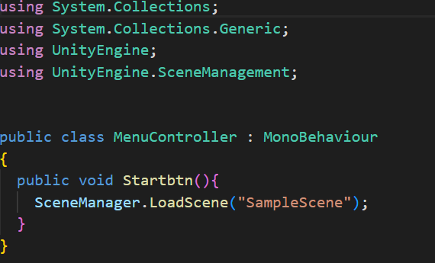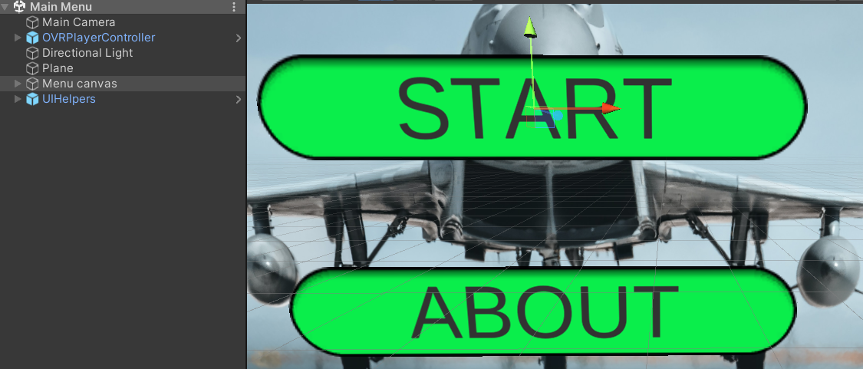

* The Main menu contains the script for controlling the **Play** and **About** buttons.
* Start Button is used to switch scenes. From the main menu to SampleScene.
* Further on, the AboutMenu contains the Back button which is used to Switch back to Main Menu.

**Script for plane flight mechanics.**

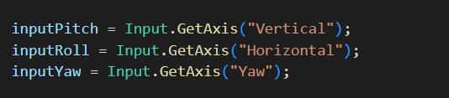

* **Horizontal**: For rotating clockwise or anticlockwise. Assigned to (D and A, respectively).
* **Vertical**: For lift and dip in air. Assigned to (S and W, respectively).
* **Yaw**: For left and right turns. Assigned to (Q and E, respectively.)

Code which helps in flight of plane:-

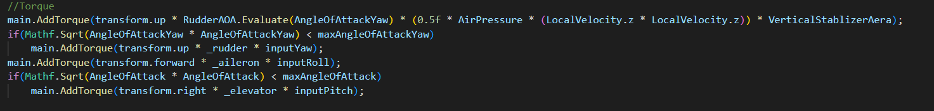

* **AddForce** function for applying thrust force causing lift and dip.
* **Add Torque** is function for applying torque causing rotation.
* **AddForceAtPosition** apply force at a particular position.
* Rest there is various updation in different variables like lift, _sidedrag.

**VR elements and camera**

Placing main camera inside the plane giving us the view of cockpit. Using VR elements and oculus integration help us to give complete realistic experience of jet plane.A picture containing sky, screenshot, outdoor

**Result**

We get complete 3d experience of plane simulation.

